Assignment 1

Introduction to Database Management System Spring 2022

Given the file structure shown in Figure 1, answer Problems 1 – 4

**Figure 1. the file structure for problem 1-4**

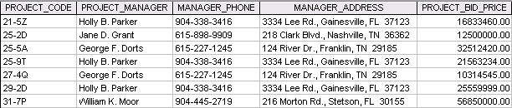

1. How many records does the file contain? How many fields are there per record?
   * This File contains 7 records, and each record has 5 fields
2. What problem would you encounter if you wanted to produce a listing by city? How would you solve this problem by altering the file structure?
   * You cannot sort by City because the city is connected to the rest of the address field. You would need to make a new City field in order to properly sort by City.
3. If you wanted to produce a listing of the file contents by last name, area code, city, state, or zip code, how would you alter the file structure?
   * IF you wanted to produce a listing of file contents by different conditions related to the Manager Address you would need a new field for each condition. For example, MANAGER_CITY, MANAGER_ZIP, MANAGER_STATE, and MANAGER_AREA.
   * This would also need to be true for the name field if you wanted to search by last name.
4. What data redundancies do you detect? How could those redundancies lead to anomalies?
   * There are 3 different Records for the Manager Holly B. Parker, all with different Project Codes and Project Bid Prices. If you wanted to find a project with this manager 3 would come up creating an anomaly when search through Project Managers.